First Day of School Quick Guide
- Be sure to have the Microsoft Teams app downloaded on a device (preferably a laptop or school issued Microsoft Surface – not a phone).
- Open the Teams app
- In the Teams app, Click on the “Teams” button on the left-side menu bar.
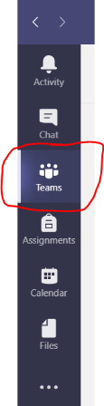

You will now likely see an overwhelming number of Teams (most of which have confusing names).
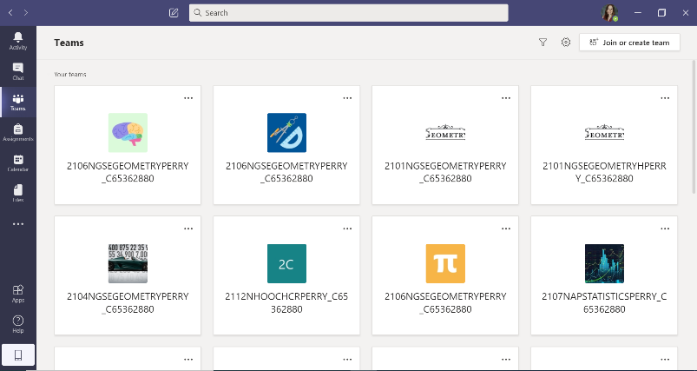

- Look for team named T880.Bennett.Classname.Period

- To join the live class, click on the channel on the left.

- Once I have started the meeting, you will see a “Join” button appear.
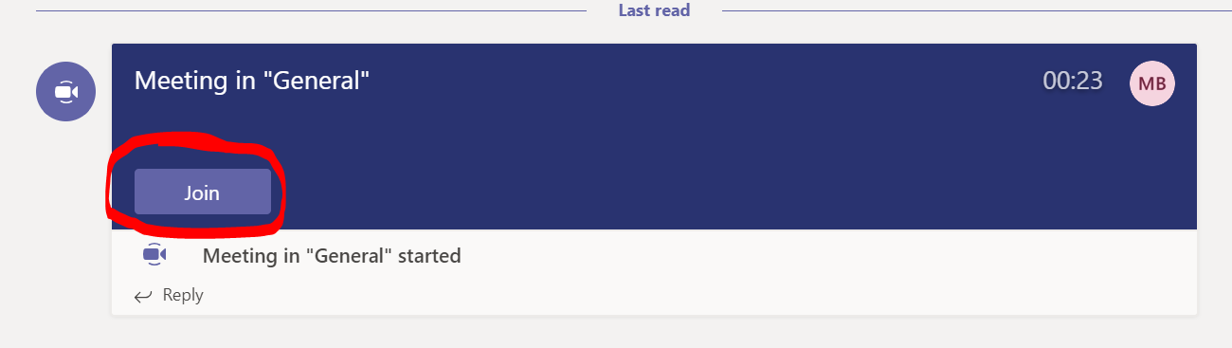

Looking forward to an awesome first day back on Monday. See you then!

